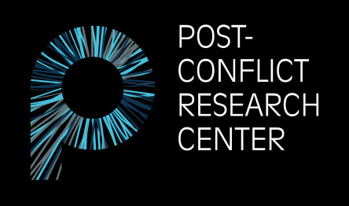

Pruščakova 21
71000 Sarajevo, Bosnia and Herzegovina
E-mail: pcrc.bih@gmail.com
Website: www.p-crc.org

FELLOWSHIP Application Form

PCRC is dedicated to restoring a culture of peace and preventing future conflict in Bosnia-Herzegovina and the Western Balkans by creating, implementing, and supporting unconventional and innovative approaches to peace education, post-conflict research, transitional justice, and human rights.
Basic Information
      - A fellowship at PCRC offers a unique opportunity to learn about Bosnia’s history of conflict as well as its present state of affairs.
      - A PCRC fellowship includes both office and fieldwork.
      - PCRC only offers unpaid fellowship.
      - We accept fellows from all over the world, all year round.
- The average duration of a fellowship is between 3 and 6 months.
- PCRC receives over 50 fellowship applications each year, therefore, the process of selection is very competitive.
Eligibility
Fellowship positions are open for people who are:
- Recent graduates, PhD students, NGO workers, and other young professionals
- Proficient in English
Skills
Required skill sets: Strong writing skills, research experience, and creativity.
Desirable skill sets: Photography, journalism, filmmaking, grant writing, website management, graphic design, editing, project development, translation, transcription, fundraising, monitoring and evaluation, policy research and analysis, and social media management.

Please answer the following questions (250 word maximum per question):
1. Why are you interested in working as a fellow for the Post-Conflict Research Center (PCRC)?
2. Briefly describe how your previous academic and professional experience makes you a good candidate for this position. What specific skills do you possess that you believe will benefit the work of our organization?
3. If you are accepted for a fellowship position, please list any specific topics and/or areas of interest you would like to explore further during your time in Bosnia and Herzegovina.
4. Please indicate which period you are applying for.
5. Please indicate whether you have any experience in the following areas and to what extent: editing, translation, academic research work, field research work, journalism, grant writing, and/or monitoring and evaluation.
6. List any additional languages spoken along with your proficiency.
7. Work samples. Please provide up to 3 links containing samples of your work (photography, articles, websites, and/or research publications).
8. Please list your country of origin and your country of residence below.
Origin: Residence:
9. Emergency contact (name, relation, phone number, and email address).
10. How did you hear about PCRC?

