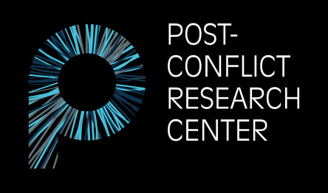

Pruščakova 21
71000 Sarajevo, Bosnia and Herzegovina
E-mail: pcrcinternships@gmail.com
Website: www.p-crc.org

Internship Application Form

PCRC is dedicated to restoring a culture of peace and preventing future conflict in Bosnia-Herzegovina and the Western Balkans by creating, implementing, and supporting unconventional and innovative approaches to peace education, post-conflict research, transitional justice, and human rights.
Basic Information
- An internship at PCRC offers a unique opportunity to learn about Bosnia’s history of conflict as well as its present situation.
- A PCRC internship includes both office and fieldwork.
- PCRC only offers unpaid internships.
- We accept interns from all over the world, all year round.
- The average duration of an internship is 3 months.
- PCRC receives over 300 internship applications each year, therefore, the process of selection is very competitive. Please refer to the Internship Information document for details regarding internship timeframes, application deadlines, and decision notification dates.
Eligibility
Internship positions are open for people who are:
- Current students, recent graduates, NGO workers, and other young professionals
- Comfortable working in English
- At least 18 years of age
Skills
Required skill sets: Strong writing skills, research experience, and creativity.

Desirable skill sets: Photography, journalism, filmmaking, grant writing, website management, graphic design, editing, project development, translation, transcription, fundraising, monitoring and evaluation, policy research and analysis, and social media management.

Please answer the following questions (250 word maximum per question):
1. Why are you interested in working as an intern for the Post-Conflict Research Center (PCRC)?
2. Briefly describe how your previous academic and professional experience makes you a good candidate for this position. What specific skills do you possess that you believe will benefit the work of our organization?
3. If you are accepted for an internship position, please list any specific topics and/or areas of interest you would like to explore further during your time in Bosnia and Herzegovina. (Examples from previous interns include art and peacebuilding, contested memorials, human trafficking, youth unemployment, transgenerational trauma, minority rights, etc.)
4. Please indicate which term you are applying for.
Spring Summer Fall
5. Please indicate whether you have any experience in the following areas and to what extent: Editing, translation, photography, film, graphic design, journalism, grant writing, and/or monitoring and evaluation.
6. List any additional languages spoken along with your proficiency.
7. Work samples (optional). Please provide up to 3 links containing samples of your work (photography, articles, websites, blogs, and/or research publications).
8. Please list your country of origin and your country of residence below.
Origin: Residence:
9. Emergency contact (name, relation, phone number, and email address).
10. How did you hear about PCRC?

