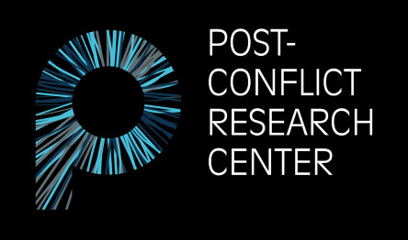

**POST-CONFLICT RESEARCH CENTER (PCRC)**

Pruščakova 21**,** 71000 Sarajevo

Bosnia and Herzegovina

E-mail: [pcrcinternships@gmail.com](mailto:pcrcinternships@gmail.com)

Website: [www.p-crc.org](http://www.p-crc.org)

**Internship Application Form**

*Post-Conflict Research Center (PCRC) is a women-led, peacebuilding organization and research center dedicated to fostering a culture of peace and preventing violent conflict in the Western Balkans by creating, implementing, and supporting evidence-based, multidisciplinary, and innovative approaches to peace education, creative multimedia, conflict prevention, post-conflict research, human rights, and transitional justice.*

**Basic Information**

* An internship at PCRC offers a unique opportunity to learn about Bosnia’s history of conflict as well as its present situation.
* A PCRC internship includes both office and fieldwork.
* PCRC only offers unpaid internships.
* We accept interns from all over the world in three separate terms: Spring, Summer, and Fall.
* There are three different internship positions available to apply for: Research Intern, Journalism Intern, Social Media Intern. While the position determines your main responsibilities, you may still be asked to contribute and assist in other areas.
* The **maximum** length of an internship is 3 months.
* PCRC does not currently have the capacity to assist with the visa application process, including providing documents. Please check the BiH government’s [website](https://www.mvp.gov.ba/konzularne_informacije/vize/Default.aspx) before applying to ensure you are able to stay in Bosnia and Herzegovina for the length of the internship without a visa.

**Eligibility**

*Internship positions are open for people who are:*

* Current students, recent graduates, activists, and other young professionals.
* Comfortable working in English.
* At least 18 years of age.

**Skills**

***Required skill sets:*** Strong writing skills, research experience, and creativity.

***Desirable skill sets:*** Photography, videography, journalism, filmmaking, graphic design, policy research and analysis, and social media management.

**Please answer the following questions (250 word maximum per question):**

|  |
| --- |
| **1. Why are you interested in working as an intern for the Post-Conflict Research Center (PCRC)?** |
|  |
| **2. Briefly describe how your previous academic and professional experience makes you a good candidate for this position. What specific skills do you possess that you believe will benefit the work of our organization?** |
|  |
| **3. If you are accepted for an internship position, please list any specific topics and/or areas of interest you would like to explore further during your time in Bosnia and Herzegovina.** *(Either on behalf of PCRC or personal interest.)* |
|  |
| **4. Please indicate which term and position you are applying for.** |
| **Term**  Spring Summer Fall    **Position**  Research Journalism Social Media |
| **5. Please indicate whether you have any experience in the following areas and to what extent:** *photography, videography, journalism, filmmaking, graphic design, policy research and analysis, social media management.* |
|  |
| **6. Please indicate whether you have any proficiency in Bosnian/Croatian/Serbian/Montenegrin (BCMS).** |
|  |
| **7. Work samples (optional). Please provide up to 3 links containing samples of your work** *(photography, articles, blogs, and/or research publications)*. |
|  |
| **8. Please list your country of origin and your country of residence below.** |
| Origin: Residence: |
| **9. Emergency contact** *(name, relation, phone number, and email address)*. |
|  |
| **10. How did you hear about PCRC?** |
|  |