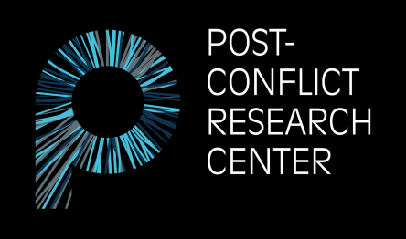
POST-CONFLICT RESEARCH CENTER (PCRC)
Pruščakova 21, 71000 Sarajevo
Bosnia and Herzegovina
E-mail: pcrcinternships@gmail.com
Website: www.p-crc.org

Internship Application Form
Post-Conflict Research Center (PCRC) is a women-led, peacebuilding organization and research center dedicated to fostering a culture of peace and preventing violent conflict in the Western Balkans by creating, implementing, and supporting evidence-based, multidisciplinary, and innovative approaches to peace education, creative multimedia, conflict prevention, post-conflict research, human rights, and transitional justice.

Basic Information
- An internship at PCRC offers a unique opportunity to learn about Bosnia’s history of conflict as well as its present situation.
- A PCRC internship includes both office and fieldwork.
- PCRC only offers unpaid internships.
- We accept interns from all over the world in three separate terms: Spring, Summer, and Fall. Please see the internship information document on our website for details on term dates.
- There are three primary roles to select from: Research, Journalism, and Social Media. While the preferred primary role determines your main responsibilities, you may still be asked to contribute and assist in other areas.
- The maximum length of an internship is 3 months. PCRC reserves the right to shorten the length of a term based on both PCRC needs and the availability of our selected interns.
- PCRC does not currently have the capacity to assist with the visa application process, including providing documents. Please check the BiH government’s website before applying to ensure you are able to stay in Bosnia and Herzegovina for the length of the internship without a visa.
Eligibility
Internship positions are open for people who are:
- Current students, recent graduates, activists, and other young professionals.
- Comfortable working in English.
- At least 18 years of age.
Skills
Required skill sets: Strong writing skills, research experience, and creativity.

Desirable skill sets: Photography, videography, journalism, filmmaking, graphic design, policy research and analysis, and social media management.

Please answer the following questions (250 word maximum per question):
1. Why are you interested in working as an intern for the Post-Conflict Research Center (PCRC)?
2. Briefly describe how your previous academic and professional experience makes you a good candidate for this position. What specific skills do you possess that you believe will benefit the work of our organization?
3. If you are accepted for an internship position, please list any specific topics and/or areas of interest you would like to explore further during your time in Bosnia and Herzegovina. (Either on behalf of PCRC or personal interest.)
4. Please indicate which term and primary role(s) you are applying for.
Term
Spring Summer Fall

Preferred Primary Role(s)
Research Journalism Social Media

**You may still be requested to assist with tasks outside of your preferred primary role(s) based on PCRC needs and skills of interns.
5. Please indicate whether you have any experience in the following areas and to what extent: photography, videography, journalism, filmmaking, graphic design, policy research and analysis, social media management.
6. Please indicate whether you have any proficiency in Bosnian/Croatian/Serbian/Montenegrin (BCMS).
7. Work samples (optional). Please provide up to 3 links containing samples of your work (photography, articles, blogs, and/or research publications).
8. Please list your country of origin and your country of residence below.
Origin: Residence:
9. Emergency contact (name, relation, phone number, and email address).
10. How did you hear about PCRC?

