Placement Details

Job title of placement: Intern. We allow for a selection of research, social media, and/or journalism within the application. These selections mark your preference(s) for your primary role(s) while with PCRC, but you may still be assigned to work on tasks outside of your selected preference(s), based on PCRC needs and your listed experience and skills.
Nature of the work/job description:
Research Tasks. Interns will contribute to PCRC’s ongoing research initiatives aimed at bolstering knowledge of successes and failures in the field of peacebuilding and reconciliation, promoting innovation, advancing understanding, and informing best practices.
Journalism and Creative Writing Tasks. Interns will be responsible for writing articles for PCRC’s Balkan Diskurs online platform and/or PCRC’s blog throughout their internship. Balkan Diskurs (www.balkandiskurs.com) is a regional multimedia network of writers, bloggers, multimedia artists, and activists who came together in response to the lack of objective, relevant, invigorating, independent regional media.
Meetings and Seminars. PCRC will organize meetings and seminars that are relevant to PCRC research. Interns will be designated with various tasks during meetings, which include writing summaries, creating posts for social media, and taking photographs.
PCRC Projects, Events and Other Tasks. Event planning, grant writing, interview transcription, editing, communications and outreach, social media management and project development tasks are often delegated throughout the internship. Some individual tasks are assigned, and some tasks are a team effort.

Approximate number of hours per week: 30 – 35
Basic structure: Interns will work in the PCRC office Monday through Friday from 10am to 4pm, aside from site visits and fieldwork. Any changes to office hours will be communicated to interns no later than the day before.
Internship timeframes: PCRC accepts interns based on the schedule detailed below. Exact dates for each term are determined each year based on the needs of PCRC and our interns. All terms last no longer than 90 days, typically less to allow for travel times. Additionally, final term dates may be shorter than listed below, but they will never be longer.
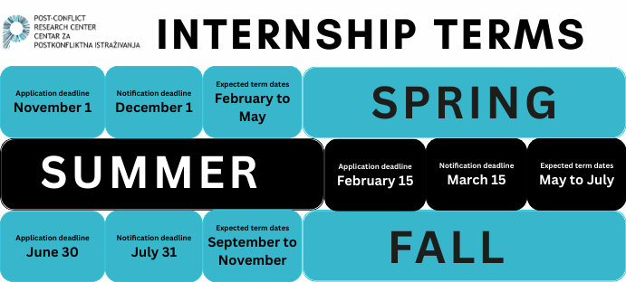

Skills
Which key skills are required? Strong writing skills, research experience, and creativity.
Required languages: English.
Desirable languages: Bosnian/Croatian/Serbian are always useful, but any second language is welcomed.
Desirable skill sets: Photography, videography, journalism, filmmaking, graphic design, policy research and analysis, and social media management.
Additional notes and comments: The PCRC internship is designed to allow our interns to explore their unique interests while creatively contributing to our overall mission. We are looking for self- motivated, self-managed, and passionate people who can bring positive energy to the PCRC team.

Frequently Asked Questions
Is accommodation provided? Interns are responsible for setting up their own accommodation. If accepted, we will provide you with information about where to find housing.
How much does housing typically cost? The average cost of housing can be anywhere from 300– 700 BAM a month (150–350 EUR, 170–400 USD). For May through September, utilities can range from 50–100 BAM. For October through April, utilities typically range from 100–150 BAM. For food, we recommend budgeting 200–400 BAM a month. The variation can depend on housing location and whether you have a roommate.
How much does the average meal cost? When eating out, a typical lunch can range from 8-12 BAM and the average dinner can range from 15–25 BAM. Espresso ranges from 2–4 BAM. Tipping is appreciated, but not required. If you want to leave a tip, 10-15% will suffice. Additional pocket money for travel and nightlife is also recommended.
Does PCRC provide any equipment? Internet access and office space is provided.
Will there be any other costs to the intern? Interns are given the opportunity to participate in optional field visits to locations outside of Sarajevo. PCRC typically covers costs for project-related activities, however, some costs such as accommodation, travel and food may be required to participate in special events. For these types of events, participation is optional.
Is PCRC able to provide any financial assistance to support internship participation? No. The intern must be able to cover his/her own living costs.
What are the visa requirements? For most countries, visitors do not need to obtain a visa before their arrival in Bosnia and are allowed to stay in country for a total of 90 out of 180 consecutive days without one. Please note that the 180 days starts from the date of your entry, and only the days that you are physically in Bosnia are counted towards your 90-day total within this timeframe. This means that if you travel outside of Bosnia, the count stops until you re-enter the country. Visa regulations have recently become much stricter, so if you exceed your 90-day limit you risk being stopped from exiting the country until paperwork has been filed and a fine has been paid. Getting caught will additionally result in a 1-year ban from the country.

